2016-2017 | American Computer Science League | All-Star Contest
SENIOR 3 DIVISION

Dear student:

Attached is the programming problem set for your division. The programs can be completed in any order. When completed save the code to your labeled storage device. Please put your school name and division on the storage device. About one hour after you start programming, proctors will be available to score your results. Your team captain and the proctor will both sign the score sheet to indicate that the scoring is accurate.

Note that the sample inputs have various numbers of examples that do not match the number of inputs indicated in the INPUT line of the program. Prior to running your program for the proctor, insure that your program can accept the indicated number of inputs.

Your outputs must stay on the screen long enough for the proctor to check them. If they scroll quickly up and off the screen they will not be scored. Your program will only be RUN once with the test data. If data is entered incorrectly, the program may be started again, but the data must be started from test input #1 again.

The only materials allowed are your authorized number of computers, pencil/pens and paper. Other electronic devices of all types and manuals can’t be used in your test room. Students using devices or manuals will cause their team to be disqualified. Students are not allowed to connect to the internet during the contest. Previously written student code is not allowed to be on your computer or among your materials.

All appeals to the programming problems must be given to the contest director prior to 1:30 PM. The appeal must be in writing. It must include a complete description of your solution. It must contain your name, school name and division.

Our current plan is to make a series of announcements to alert you that 30 minutes, 15 minutes, 5 minutes and 1 minute remain in the contest. At the end of the contest, students should move away from the computers and wait for proctors to score any remaining unscored programs. If a program is tested after the end of the contest, it will have an execution time limit of 10 minutes. Programs tested prior to 12:30 PM must be completed by 12:40 PM.

At the end of the contest the proctor will collect your team score sheet and your labeled storage device. Please put your school name and division on the storage device. Save your programs using the program names provided at the top of each program sheet. The storage device will be used to re-score programs that are appealed. If flash drives are used, they will be returned at the awards ceremony.

Below is the listing of the programs for your division. The order and point values are not indications of the level of difficulty.

ASCENDING 10 pts
NUMBERS 36 10 pts
CHEN 10 pts
TREES 10 pts

Good Luck!

Program #5 Ascending

2016-2017 | American Computer Science League | All-Star Contest
PROBLEM: Similar to Contest #2, this program requires you to take a string of digits and print out an increasing sequence of positive integers separated by a single space. The rules for computing the sequence of numbers is, however, a bit different.

INPUT: There will be 10 lines of input. Each line will contain a string of digits. The length of the string will be between 2 and 128, inclusive. The first digit in the string gives the length of each number in the outputted sequence. That digit is not part of the string of digits to use!

OUTPUT: Each output will be a sequence of ascending positive integers, separated by a single space. Numbers to be output are formed by selecting digits from the string, using each digit just once, so as the next integer is the next integer larger than the previous one. Ignore any leftover digits. Leading zeroes are never part of a number in the output series. We guarantee that there will always be at least one number in the output sequence.

In Sample Input #1, the first digit, a 2, indicates that the all integers in the output sequence will be 2 digits. The smallest 2-digit number is 12. The 12 is the first number in the sequence. Now search the remaining digits of the string to find the next largest integer that can be formed from the remaining string 575859. The two 5s are combined to form 55. Those 5s can’t be used again. There is a third 5 that can be combined with the 7 to form 57, the next number in the sequence. The remaining digits 8 and 9 are combined to form 89. The digits are all used. If there are digits left that can’t be combined to add to the ascending sequence, those digits are ignored.

SAMPLE INPUT  - 225758519  - 33141592965  - 220162017  - 119782017  - 3144  - 521431081  - 32121121112  - 144  - 41021324354  - 73201564 | SAMPLE OUTPUT  - 12 55 57 89  - 112 345 569  - 10 12 20 67  - 1 2 7 8 9  - 144  - 10112  - 111 112 122  - 4  - 1012 2334  - 1023456

Program #6 Numbers 36

2016-2017 | American Computer Science League | All-Star Contest
PROBLEM: Given a large number in base 36, find the value when its digits change places to produce the following:

- The smallest possible number.
- The largest possible number.
- The 50th largest possible number.
- The k^{th} smallest possible number. You’ll be given the value of k.
- The number closest to the mean of the first two answers above. By “closest”, use the absolute value: 4 is closer to 7 than 9 is. If there is a tie print both.
Express your answer in base 36, with no leading 0s. Base 36 uses the digits 0 through 9, followed by the letters A through Z.
INPUT: Two sets of data. Each set consists of a large integer (less than 10 digits) in base 36, followed by k, a positive integer in base 10. To avoid possible confusion when entering data, the inputs will not use the letters I or O.
OUTPUT: Print the 5 numbers as listed above. Do not print any leading 0s.

SAMPLE INPUT | SAMPLE OUTPUT
1. 12FKA, 89 | - 12AFK
2. 3BG4DH0, 2360 | - KFA21
 | - AKF12
 | - FAK12
 | - AKF21
 | - 34BDGH
 | - HGDB430
 | - HG4DB03
 | - B3G40HD
 | - B034DGH

Program #7 Coordinates Happily Embrace Notation (CHEN)
2016-2017 | American Computer Science League | All-Star Contest
PROBLEM: Given a triangle and a line that divides it into a triangle and a trapezoid, find the area of the small triangle.
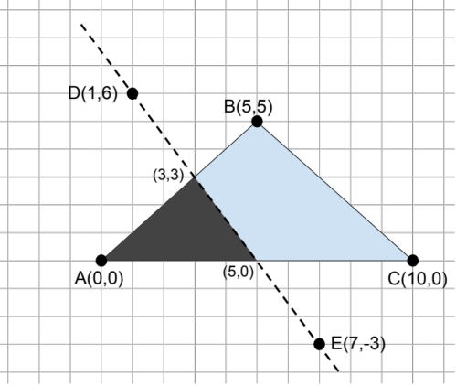
In the diagram below, line DE intersects triangle ABC along sides AB and AC. The area of the small triangle is 7.5
USEFUL FORMULAE: The distance between the point at and the point at is:

The area of a triangle with sides of length , , and , and
semi-perimeter , where , is given by Heron’s Formula:

INPUT: The first line will consist of N, followed by N ordered pairs of integers. These will represent points A, B, C, D, etc. in the plane. There will then be 10 lines, each containing two strings: the vertices of a triangle followed by two points forming a line. The points in the sample data below corresponds to the 5 points in the diagram, plus a point F at (8,6).

We guarantee that each line will divide the triangle into two pieces: a triangle and a trapezoid.

OUTPUT: For each of the 10 triangle/line pairs, report the area of the small triangle. Answers much match our answers to within one hundredth.

SAMPLE INPUT  1. 6, 0, 0, 5, 5, 10, 0, 1, 6, 7, -3, 8, 6  2. ABC, DE  3. CBA, DE  4. ABC, FE  5. DEB, AF  6. EDB, AC  7. DAC, EB  8. BEF, CD  9. BEC, AF  10. ADC, EF  11. ABE, CD | SAMPLE OUTPUT  1. 7.5  2. 7.5  3. 3.2  4. 7.961  5. 1.875  6. 5.625  7. 5.043  8. 0.282  9. 2.207  10. 1.25

Program # 8 Trees
2016-2017 | American Computer Science League | All-Star Contest
PROBLEM: Build a binary search tree and find the value for each of the following:
- Depth of the tree
- Number of leaf nodes
- Number of nodes with one child
- Internal path length
- External path length

Keep in mind that duplicate keys are inserted into a binary search tree as if they were less than their equal key already in the tree.
Here is the binary search tree from the letters A M E R I C A N:
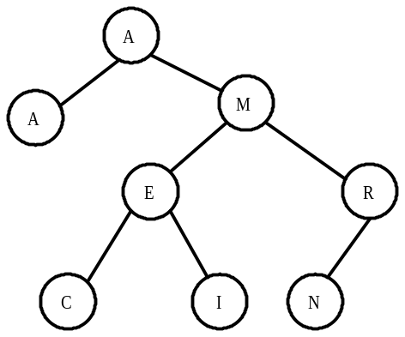
The tree has a depth of 3; there are four leaf nodes (A C I N). The only node with one child is R. The tree has an internal path length of 15: the sum of the depths of all nodes. It has an external path length of 31: the sum of the depths of all external nodes.

INPUT: There will be 2 lines of input, each line will be a string. Ignore all characters in the string other than letters. The string is case-sensitive. That is, the uppercase “M” (ASCII 77) is different than the lowercase “m” (ASCII 109). Be sure to follow the convention that all uppercase letters are less than all lowercase letters.
OUTPUT: For each input string, print the 5 statistics listed above in the order listed above.

SAMPLE INPUT  1. Winnie the Pooh and Tigger too  2. Cinderella and her evil stepsisters | SAMPLE OUTPUT  1. 7  2. 7  3. 12  4. 103  5. 153  6. 8  7. 9  8. 14  9. 141  10. 203

